Article

The Globally Harmonized System of Classification and Labelling of Chemicals – explaining the legal implementation gap

Linn Persson 1,*, Sylvia Karlsson-Vinkhuyzen2, Adelene Lai 1, Åsa Persson1 and Stephen Fick1

1 Stockholm Environment Institute, Linnégatan 87D, Box 24218, 10405 Stockholm, Sweden

2 Wageningen University & Research, Public Administration and Policy Group; sylvia.karlsson-vinkhuyzen@wur.nl

**\*** Correspondence: linn.persson@sei-international.org; Tel.: +46-73-4604647

Academic Editor: name

Received: date; Accepted: date; Published: date

**Abstract:** The Globally Harmonized System for Classification and Labelling of Chemicals (GHS) is an international standard for documenting chemical safety information. The GHS is one of the cornerstones of sound chemicals management, an issue consistently on the international sustainable development agenda since 1992. In 2002, it was agreed under the United Nations that all countries should be encouraged to implement the GHS by 2008. However, to date, it is unclear where, how, and to what extent the GHS has been implemented and what factors best explain any differences in implementation coverage. The aim of this paper is to provide a global overview of current GHS implementation status in national legislation using primary and secondary data, and discuss differences between countries based on theory on motivational and capacity-related factors for implementation of international standards. We conclude that there seems to be broad support from countries for enhanced international collaboration in the field of sound chemicals management. However, several drivers and barriers for national GHS implementation co-exist, and there is a clear positive correlation between the financial and regulatory capacities of a country and its GHS implementation status. At the same time, our data suggest that it is possible to increase the global implementation coverage by using a combination of motivational and capacity related strategies.

**Keywords:** chemicals management; classification and labelling of chemicals; GHS; global standards

1. Introduction

governments and intergovernmental organizations have long been active in .Building on this legacy of international standards – whether motivated by trade facilitation, or environmental and social sustainability concerns – the Globally Harmonized System for Classification and Labelling of Chemicals (GHS) is a system for classifying and labelling chemicals according to the nature and severity of hazard, and specifying how information about hazards should be communicated to users in the form of hazard pictograms, hazard statements and Safety Data Sheets [1]. As an internationally agreed system for standards on classification and labelling of chemicals, GHS can be considered a cornerstone of sound chemicals management, aiming for increased sustainability in the production and use of chemicals. Having GHS in place enables downstream risk-reducing activities such as employing best-practice handling, storage, and disposal methods. The characteristics of a given chemical (e.g., type of toxicity) have to be established in order to take the necessary steps to regulate and manage it safely and sustainably throughout its life cycle.

The need to have an internationally harmonized system for classification of chemicals as part of a sound system of chemicals management was first raised in the United Nations (UN) in 1992 in Agenda 21 [2] in response to unsustainable management of chemicals resulting in considerable risks for human health and ecosystems [3–5]. Ten years later, in 2002, at the World Summit on Sustainable Development (WSSD), UN member states decided to; “[e]ncourage countries to implement the new globally harmonized system for the classification and labelling of chemicals as soon as possible with a view to having the system fully operational by 2008.” (paragraph 23 c) [6]. Agenda 2030 adopted in 2015 also includes the target (12.4) to “[b]y 2020, achieve the environmentally sound management of chemicals and all wastes throughout their life cycle, in accordance with agreed international frameworks”. Global GHS implementation has thus been an objective of the international community for more than two decades and is seen as a key element in sustainable development governance.

The GHS was initially developed under the auspices of the [Interorganization Programme for the Sound Management of Chemicals](http://www.who.int/iomc/) (IOMC), a UN initiated programme, through its Coordinating Group for the Harmonization of Chemical Classification Systems. Through [resolution 1999/65](https://www.unece.org/fileadmin/DAM/trans/main/dgdb/dgsubc4/ECOSOC/1999-65/1999-65e.pdf) of 26 October 1999, the UN Economic and Social Council (ECOSOC) decided to enlarge the mandate of the Committee of Experts on the Transport of Dangerous Goods by reconfiguring it into a Committee of Experts on the Transport of Dangerous Goods and on the Globally Harmonized System of Classification and Labelling of Chemicals, and by creating a new Sub-committee of Experts on the Globally Harmonized System of Classification and Labelling of Chemicals ([GHS Sub-Committee](https://www.unece.org/trans/main/dgdb/dgsubc4/c4age.html))[7]. The experts attending the meetings of the sub-committee are nominated by countries that have applied to ECOSOC to become members of the sub-committee [8]. GHS was developed based on the four major existing systems: 1. The requirements of the USA for the workplace, consumers and pesticides, 2. Requirements of Canada for the workplace, consumers and pesticides, 3. European Union directives for classification and labelling of substances and preparations, and 4. The United Nations recommendations on the transport of dangerous goods [9]. The [first edition of the GHS](https://www.unece.org/trans/danger/publi/ghs/ghs_rev00/00files_e.html), intended to serve as the initial basis for the global implementation of the system, was adopted by the Sub-committee in December 2002 and published in [2003 [10].](https://www.unece.org/trans/danger/publi/ghs/ghs_rev00/00files_e.html) The GHS has since then been regularly updated through decisions in the GHS Sub-committee, with the seventh revision released in 2017 (revisions include for instance new hazard classes, as well as changes in labelling requirements and safety data sheet composition)[11].

As an internationally agreed system, the GHS can be defined as a global voluntary best-practice rule [12]. It was called for and developed by states in various fora and later included in the Strategic Approach to International Chemicals Management (SAICM), adopted by stakeholders at the International Conference on Chemicals Management in 2006 [13]. SAICM is a collaborative process among multiple stakeholders including business actors and non-governmental organizations, the decisions of which are non-binding and fall in the realm of voluntary regulation [14,15]. Under SAICM, the implementation of GHS has been identified as one of eleven basic elements of sound chemicals management [16].

Despite the fact that the GHS has been in place for fifteen years, it is unclear where, how, and to what extent it has been implemented and what factors best explain any differences in implementation coverage. The aim of this paper is to provide a global overview of the current national GHS implementation status (defined here as passing of national legislation on GHS) based on primary and secondary data, and explore possible explanations for the differences in GHS implementation between countries based on theory-derived motivational and capacity-related factors for implementation of international standards. Finally, we identify strategies for closing the widening gap among developed and developing countries in pursuing sound chemicals management.

The paper proceeds with a section on theory and methods, where first the approach to mapping of GHS implementation status is presented. Thereafter, factors for explaining implementation status are derived from theories on international standards. These factors are then operationalized into indicators. In the subsequent sections, the results of the global implementation overview are presented and the relationships between implementation status and various explanatory factors are analysed. In the concluding section, we summarise the key results on explanatory factors and discuss possible strategies to strengthen global implementation of the GHS.

2. Theory and Methods

2.1. GHS implementation status

Turning to our dependent variable, the GHS covers four sectors: the transport, workplace (industrial), consumer and agricultural sectors. Since the transport sector has its own international system (UN Recommendations on the transport of dangerous goods: model regulations)[17], it is not included in this study. The GHS uses a modular, building-block approach to enable custom-made solutions for GHS implementation for individual countries. There is thus scope for flexible implementation, which causes an inherent tension between harmonization and differentiation. Some countries have chosen to implement GHS as a non-binding, voluntary standard for companies, and others as a legally binding requirement [18,19]. The GHS is regularly updated under the GHS sub-committee [7] and so far seven revisions have been published: [GHS Rev.1 (2005)](https://www.unece.org/trans/danger/publi/ghs/ghs_rev01/01files_e.html), [GHS Rev.2 (2007)](https://www.unece.org/trans/danger/publi/ghs/ghs_rev02/02files_e.html), [GHS Rev.3 (2009)](https://www.unece.org/trans/danger/publi/ghs/ghs_rev03/03files_e.html), [GHS Rev.4 (2011)](https://www.unece.org/trans/danger/publi/ghs/ghs_rev04/04files_e.html), [GHS Rev.5 (2013)](https://www.unece.org/trans/danger/publi/ghs/ghs_rev06/06files_e.html), [GHS Rev.6 (2015)](https://www.unece.org/trans/danger/publi/ghs/ghs_rev06/06files_e.html#c38156) and GHS Rev. 7 (2017). Some countries have implemented a specific version of the GHS and lack mechanisms for updates [18,19].

We propose here that the implementation process of GHS encompasses three stages: (1) formal adoption by states, (2) incorporation into national legislation, and (3) facilitation and enforcement of uptake and use of GHS among companies and any other relevant actors. Knowing that the introduction of the GHS has already been formally agreed by UN member states in Johannesburg, we focus in this paper on the second stage, and refer to this as implementation. The third stage of enforcement and compliance within states is beyond the scope of this study but merits further research.

Since the GHS can be legislated at the national level in different ways, there is no single answer to the question of when a country can be said to be implementing the GHS and when not [see for instance 18]. For the purpose of this study, the following classification categories are used:

* **Full legal implementation** (code 2): legislation passed for both substances and mixtures[1] (as of April 1st 2017), but irrespective of which GHS revision the legislation is based, covering the workplace, agriculture and consumer sectors.
* **Partial legal implementation** (code 1): legislation passed, covering at least one of the sectors agriculture, workplace or consumers.
* **Not yet implemented** in legislation (code 0): no legislation aligned with the GHS has been passed.

GHS is thus categorized here as fully implemented when a country has passed legislation to use GHS in all sectors. To further clarify the criteria:

* Only binding legislation qualifies for “full” or “partial” implementation, whereas implementing it as a voluntary standard at the national level is classified as “not yet implemented”.
* If a country has passed legislation to implement GHS in all three sectors, the country is coded as fully implementing GHS, even if the legislation has not yet entered into force. Most countries who do implement GHS do so in a stepwise manner and the majority of the GHS-implementing countries have introduced phase-in periods in the regulation with additional upcoming deadlines, e.g. for substances and mixtures.
* Even if GHS implementation is fully in force in one sector, it does not qualify as “full implementation” if there are no legal requirements for the remaining two sectors.
* The scoring of countries’ implementation status is irrespective of which revision of GHS has been introduced.

That only implementation through legislation is coded as implementation could be contested on several grounds, for example that different countries have different regulatory culture or that the GHS is not legally binding in nature. However, we propose here that legislative backing is necessary for effective enforcement and compliance with the GHS. For instance, without legal mandate it is not possible for authorities to carry out inspections at workplaces or for customs authorities to ensure compliance of labelling regulations at the border controls.

It should also be noted that in many countries there are ongoing legislative processes and that the global GHS implementation status is constantly developing. This study shows the snap shot picture of implementation as of 1st April 2017.

2.2. Method for data collection and analysis

Our dataset on GHS implementation status is available in Table S1 and draws on both primary and secondary sources. As a secondary source, the progress reports compiled by the secretariat of the GHS Sub-committee [1] were used for a first overview of the global implementation status. Since there is no reporting requirement connected to the GHS, the information available on the website of the GHS Sub-committee secretariat relies on self-reporting by countries on a voluntary basis or on information otherwise made available to the secretariat. There is no fixed format and the type of information available varies between countries. The listing is thus not offering a complete picture of the implementation and currently includes varying levels of information for 72 countries (by 1 April 2017), out of the 179 countries having committed to the SAICM process by appointing a national SAICM focal point (by March 2017) [20]. Other secondary sources were an overview of GHS implementation published by the European Chemical Industry Council [21] and the resources supplied by the company DHI [22]. Countries have also reported on GHS implementation as part of the reporting under SAICM. However, the baseline report covering the period from the start of SAICM in 2006 to 2008 notes that the information submitted by governments on SAICM indicator 6 (providing information according to internationally harmonized standards) is not sufficiently precise nor comprehensive to assess GHS implementation status specifically. The report notes that 33 percent of reporting governments state that they are using a harmonized standard, but that this may also be something else than GHS, such as the FAO guidelines on pesticides, and that there is no detail in the country reports on the stage of implementation [23]. Therefore, this reporting was not used to assess GHS implementation of individual countries.

The secondary sources were complemented with our own web-based searches for country or regional specific information, with a focus on countries that did not have information displayed on the GHS Sub-Committee website. This was done by combining the country name with GHS in a general internet search engine[2] to find any GHS-related material for a specific country, as well as searches of websites of Ministries of Environment and other Ministries of specific countries. For the Latin American region, the Spanish name and acronym for the GHS was used (SGA) which resulted in additional information. A limitation of the study is that searches in additional languages were not conducted. However, for countries that have taken part in international collaboration on chemicals management, there will often be a report or a note in English that appears in the internet search, if GHS implementation has indeed taken place.

A set of short interviews (see Table 1) by skype, telephone and in written form by email were also carried out with government officials in charge of GHS implementation at the national level, UN organization officials, representatives of business associations, academic experts and representatives of donor countries. Nine additional requests for interviews were sent out but not responded to. The selection of interviews was made by 1). Following up with some countries who received support from UNITAR in developing national implementation strategies for GHS, and 2). Seeking information for some of the countries for which no GHS related information could be found through secondary sources or internet searches, 3) where clarifications were needed on information in government documents, and 4) input from representatives of private sector, academia and Intergovernmental organisations. The questions addressed in the semi-structured interviews included the GHS implementation activities in specific countries, as well as perceived barriers and opportunities for legislating GHS. The information collected fed into the classification of GHS implementation status of countries, as well as to the discussion on possible explanatory factors. In addition, one of the authors attended the 33rd session of the GHS sub-committee of experts in Geneva 10-12th of July 2017 as observer. Preliminary results of this study were presented at the session of the Sub-committee and feedback invited.

**Table 1**. Interviews and information requests

|  |  |  |  |
| --- | --- | --- | --- |
| **Name** | **Organisation** | **Position** | **Date and location of interview** |
| Ms. Adriana Jalba | Cefic (former) | Manager International Chemicals Management | 20161107, by telephone. |
| Mr. Oliver Wootton | UNITAR | Training Associate, Chemicals & Waste Management Programme | 20161116, by skype |
| Ms. Liz Anderson | RPMASA, Responsible Packaging Management Association of Southern Africa, South Africa | Executive director | 20161130, by skype |
| Mr. Fabián Benzo | Unidad Académica de Sistemas Integrados de Gestión  Facultad de Química – Universidad de la República, Uruguay | Prof. Agregado – Director | 20161201-02, by email |
| Mr. Maxwell Nkoya | Zambia Environmental Management Agency (ZEMA), Zambia | Director-operations | 2017-09-29, by phone and email |
| Mr. Philip Pile | Environmental Protection Department, Barbados | Environmental Technical Officer | 20170116, by email |
| Mr. Lennart Dock | International Unit, Swedish Chemicals Agency (KemI) | Programme Manager, Senior Adviser | 20150519 and 20161212, at KemI |
| Ms. Jelena Kovacevic | Ministry of Sustainable Development and Tourism, Montenegro | Head of Department for industrial pollution and control and chemicals | 20170529, by email |
| Ms. Natalia Druzhinina | Coordinating Informational Center of CIS  Member States on approximation of regulatory  practices, Russia | Leading expert of Chemicals safety, Department  Consulting  Partnership | 20170116, by email |
| Ms. Yuwaree Inna | Independent consultant, Thailand | Chemicals management expert | 20170529, by email |

Having used these primary and secondary data to classify individual countries’ GHS implementation status (implementation codes and links to legislation is available in table S1), the indicators proposed below (Table 1) for potential explanatory factors were collected for all UN member states. For each indicator, the data set for the latest available year was used. Individual associations between the indicators and GHS implementation status were evaluated via two-sample t-tests and Pearson's Chi-squared test with Yates' continuity correction for continuous and categorical indicators, respectively. We also tested the association of indicators with GHS status after accounting for the effects of other indicators via logistic regression, using the glm function in R [24] with scaled and centered indicator data. Although data used in this study technically represent a census of all countries (rather than a statistical sample of a larger population), our interest in these analyses was primarily understanding whether the processes generating the observed outcome (GHS implementation status) were random or systematically related to explanatory factors, for which t-tests and other inferential methods may be suitable approximations of complete randomization tests [25]. For the statistical tests, the groups of countries with “full” and “partial” implementation were merged to one group and compared to the “no implementation”. The statistical analysis is available at <https://github.com/sei-international/GHS>.

2.3 Understanding international standardization

The analysis for addressing what (types of) factors that can explain differences in implementation among countries, is grounded in theories about how and why countries implement international rules or norms[3]. We here draw on two partly separate literatures for identifying possible explanatory factors for the differences in GHS implementation among countries.

The first relevant literature theorizes how international norms influence state behavior. Much of this literature focuses on legally binding norms, thus international (hard) law, and proposes various categories of explanatory factors and theories. Raustiala [27] summarizes the explanatory theories into three categories: rationalist, norm-driven and liberal theories. Another categorization is between theories considering that states primarily behave within a framework of consequences and theories and according to a logic of appropriateness [28]. While these theories are often posed as alternative explanations, they can be approached as plausible complementary explanations [29]. As noted above, the international agreement to implement GHS does not fall within the legally binding (hard law) norm category. However, while there are claims that legally binding norms have more influence on state behavior – i.e., a higher degree of implementation, uptake and actual enforcement [30,31] – the basic mechanisms through which international soft law can have influence are largely the same as for hard law [28]. One reason for this is that the option of material sanctions (economic or military) is seldom used to induce compliance with international hard law. Soft sanctions, primarily in the form of reputational damage (see Guzman [32]), can be associated both with international hard and soft law.

Understanding the GHS as an international norm, we have with these considerations in mind narrowed down the plausible explanatory factors for GHS implementation into two categories that, however, can overlap and interact: 1) motivational factors that come from countries’ self-interest overlapping with the norm; 2) capacity related factors associated with the countries’ ability to implement the norm.

The second relevant body of literature for understanding differences in GHS implementation is that on international standards and their regulation of global business. This body of literature theorizes the development of international standards, primarily product-related standards by non-state standard development organizations, including the motivational factors that make companies and their associated governments seek to influence and adopt particular international standards. Mattli and Büthe [33] summarize three explanatory theories; sociologist institutionalism (related to constructivism) in which actors are expected to mostly behave according to the logic of appropriateness according to their role identities, realism in which states are seen as the primary actors in an international society where power defined as resources is hugely influential and their own institutionalist complementarities approach that highlight role of the variation in complementarity of national and international regulatory standardization. Each of these three approaches adds further depth to the motivational and capacity-related factors as will be discussed below. The GHS is not a traditional product standard as it does not specify properties and performance of the manufactured good itself. Rather, the GHS is a technical standard that regulates the information that needs to accompany chemicals as they are traded, transported and used. In functional terms for companies it can be seen as a product standard although implementation, as discussed in this paper, is at the level of states who provide regulation on chemicals in various sectors. In the next two sections, we discuss possible motivational and capacity-related factors that can influence GHS implementation drawing from these two literatures and, when possible, identify indicators for testing their relevance empirically.

2.3.1 Motivational factors

Factors that influence the motivation of states to adhere to international norms can include both material benefits and reputation (perceived identity and what is seen as acceptable behaviour for states). The expected relative weight of these factors is an open question, the answer to which is influenced by the choice of theories for explaining state behavior briefly mentioned above.

When considering motivation to implement GHS, it should be noted that the objectives of GHS can be understood and framed in two ways. One objective is to provide an internationally harmonized system for trade facilitation and business promotion. A second objective is to improve chemical safety for people and the environment, across the world. The relative support for and identification with each of these objectives is likely to influence the motivation of states to invest in the adherence to the GHS.

In line with the first objective, internationally harmonized standards such as GHS are seen as having the potential to lower transaction costs and facilitate international trade [34]. Global standards applicable within specific sectors constitute part of the harmonization process of business regulation that is pervading field after field [35]. When the TBT Agreement requires countries to use international rather than national standards for products, this is also an expression of seeing international standards as trade facilitation tools. The development of international product-related standards is seen as an issue of coordination, simple or more challenging depending on theoretical perspective [33]. Applying this logic to GHS, it can be motivational for states to implement GHS as part of a general pursuit of trade openness and reduction of trade barriers. In this study we use two indicators to examine the role of this factor: WTO membership and the Trade Openness Index [36] reported by the United Nations Conference on Trade and Development (UNCTAD) (see Table 1).

Regarding reputation as a source of motivation, it should be noted that for a relatively technical measure with low public salience such as the GHS, we can expect that reputational risk associated with non-implementation is perceived as relatively low and therefore a weak motivational factor. However, we can consider potential positive non-material motivational factors, whether related to a state’s positive reputation in the international community or its innate belief in and commitment to international norms generally or for specific issues. To be more specific, and considering the second objective of GHS outlined above, states may find motivation in GHS as a means to improve occupational health and safety. Such motivation can come from a state’s long-standing commitment to the issue and/or domestic or international political pressure, often channeled through organized civil society (trade unions, environmental Non-Governmental Organisations etc.). Indeed, the GHS originated from the occupational health and safety context. The number of ratifications of chemical related ILO conventions is used as an indicator here (conventions 155, 170, 174). These conventions are from the 1980s and 90s and ILO has since this time moved away from conventions and instead use non-binding declarations [37]. The ratifications that are already there, though, can be seen as an expression of a long-term commitment to occupational health and safety. States can also base motivation to implement GHS in its the commitment to the sound management of chemicals. In this study, we include as indicator for this motivation the ratification of the chemical-related conventions (Stockholm, Rotterdam and Basel) together with the nomination of a national SAICM focal point (as SAICM is not a binding agreement with ratification procedures), as a way of expressing political support and commitment to the sound management of chemicals.

If we zoom out from motivation to adhere to international norms in the field of chemicals, environment and health, the implementation of GHS can be seen in the light of a general commitment to international cooperation as such. Countries may wish to implement international standards because doing so reinforces a sense of community with other countries in a globalized world where problems are becoming increasingly jointly addressed. In this study, we use the political globalization sub-index of the KOF index of globalization [38,39], to explore the interlinkage between the GHS implementation status and this commitment. The four components of the political globalization sub-index are; presence of embassies in the country, membership in international organisations, participation in UN Security Council Missions and in international treaties [38,39].

2.3.2 Capacity-related factors

The capacity to implement GHS requires having resources at disposal for developing new or adjusting existing legislation and guidance. GHS is a technical standard and as such it requires a high level of technical knowledge, in addition to budgetary space for implementation costs and staff time in ministries and agencies. For the purpose of this study, capacity is categorized into financial and regulatory capacity (Table 1). Firstly, financial capacity, is represented here by the two indicators GDP and GDP per capita. These two indicators relate to the overall size of the economy which sets the frame for financial and thus also human resources of the public sector. While the total GDP shows the total size of the economy, the GDP per capita reveals the size of the economy related to the number of citizens. Regulatory capacity, finally, is represented by an indicator on government effectiveness developed by the Worldwide Governance Indicators project. The government effectiveness indicator is based on perceptions of “the quality of public services, the quality of the civil service and the degree of its independence from political pressures, the quality of policy formulation and implementation, and the credibility of the government’s commitment to such policies” in a certain country. The data sources include surveys of firms and households and expert assessments of commercial business information providers, non-governmental organisations, multilateral organization and other public sector bodies [40] .

**T**able 1. Possible factors influencing states’ implementation of GHS and their indicators

|  |  |  |
| --- | --- | --- |
| **Factor** | **Indicator** | **Comment** |
| **Motivational factors** |  |  |
| *Reduction of trade barriers* | WTO membership |  |
|  | Trade Openness Index |  |
| *Commitment to occupational safety* | ILO convention ratifications | ILO conventions related to occupational safety of hazardous chemicals: ILO 155, ILO 170 and ILO 174 1 |
| *Commitment to sound management of chemicals* | Ratification of the chemical conventions | The Stockholm, Basel and Rotterdam conventions[4] |
|  | Participation in SAICM | Appointment of a SAICM focal point |
| *Commitment to international cooperation* | KOF sub-index on political globalization |  |
| **Capacity related factors** |  |  |
|  |  |  |
| *Financial capacity* | Total GDP | Reflects size of economy and total financial resources for public sector |
|  | GDP/capita | *Ibid.* |
| *Regulatory capacity* | Government Effectiveness |  |
|  |  |  |

1 ILO convention 155 on Occupational health and safety convention (1981), ILO convention 170 on Chemicals (1990), and the ILO convention 174 on the Prevention of major industrial accidents (1993). For further information see the ILO website: <http://www.ilo.org/dyn/normlex/en/f?p=NORMLEXPUB:12000:0::NO>:::

3. Mapping of GHS implementation

Based on the collected data we conclude that as of April 2017, a total of 50 countries (26% of UN Member States) had fully implemented GHS, 15 countries (8%) had partially implemented, and 128 countries (66%) had not yet implemented GHS. Looking at regional patterns (see Figure 1), “full” GHS implementation is most common in Europe, and parts of Central Asia, East Asia and Southeast Asia. In Latin America, there is one country that has fully implemented the GHS, Ecuador, and two in Africa which have done so (Zambia and Mauritius).

Most of the 15 countries classified as “partially” implementing GHS were so because implementation was limited to the industrial workplace, and did not include the consumer and agriculture sectors. These countries are the US, Canada, Mexico, Brazil, Argentina, Uruguay, Japan, Singapore, Malaysia, Australia, New Zealand, Philippines and Thailand. In addition, there are two countries (Montenegro and Georgia) that are in the process of implementing GHS across all sectors as a part of ongoing EU accession, but where legislation is not yet passed for all sectors.

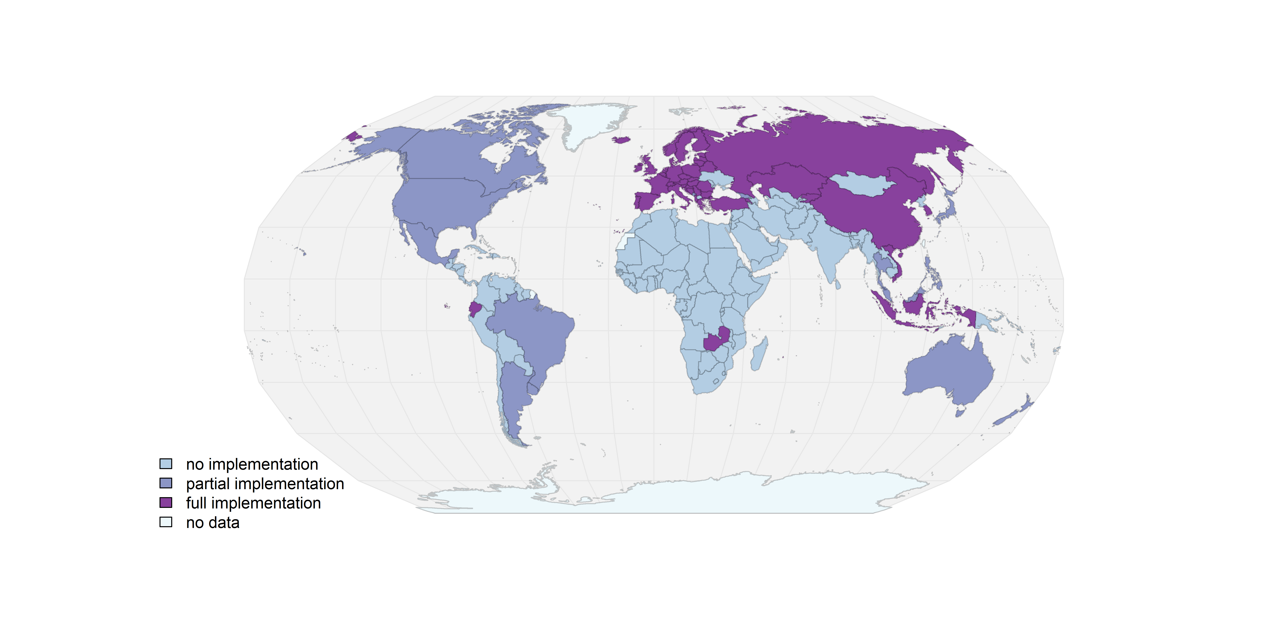

Figure 1: World map of current GHS implementation.

It is noted that the African region is still largely outside the GHS system. The member states of the South African Development Community (SADC) have agreed to implement the GHS by the latest 2020 and there is a draft GHS policy for the community [41], but this has not yet led to national legislation in most countries. In South Africa, GHS has been implemented as a voluntary standard since 2008, and is expected to be passed as regulation during 2017, but no official texts have yet been released [21,22].

The Arab countries differ considerably in terms of chemicals legislation [42] but to our knowledge none have to date implemented the GHS. The Gulf Cooperation Council (GCC)[5] put forth the “Common System for the Management of Hazardous Chemicals” in 2002, which establishes minimum legislation for the member states in dealing with hazardous chemicals and also has coordinated procedures among Member States established in 1997 for trans-border handling of hazardous waste for the purpose of processing, recycling or disposal [43]. However, there is no information to support that this legislation is aligned with GHS.

4. Exploring the implementation pattern

Below we use the factors and indicators identified above (Table 1) to seek to explore and discuss possible explanations of the observed differences in implementation coverage across regions and countries.

4.1. Motivational factors

4.1.1. Reduction of trade barriers

For the factor related to a general commitment to facilitating trade and reducing trade barriers, we look at WTO membership and the trade openness index. Turning first to the WTO membership, 34 countries are not members of the WTO whereas 159 are. We find that of the countries which have implemented GHS, WTO members make up a larger share (38%) compared to among non-WTO members (15%) (**T**able 2) and there is an association between WTO membership and GHS implementation (*X2 = 5.66, df = 1, p = 0.017*). Among the five non-WTO members that have implemented GHS, three are in the process of accession to the WTO (Serbia, Bosnia and Herzegovina, and Belarus) so this group will become very small [44]. However, more than half of all WTO member countries (99) have not yet implemented GHS (**T**able 2). As for the group of 29 countries who are not WTO members and who have not implemented GHS, this group comprises several fragile, new or very small states, which suggests that a lack of capacity (see below) might be an equally or more important factor for not being WTO members, than their interest (or lack thereof) in reducing trade barriers. It was noted by the interviewee from Zambia, that a greater awareness about the potential of GHS as a trade facilitating measure, would increase the motivation of countries to implement the GHS. This is an interesting observation that could not be further corroborated in the limited set of interviews of this study, but that merits further exploration.

**T**able : WTO membership and GHS implementation (full or partial)

|  |  |  |
| --- | --- | --- |
|  | WTO members | Non-WTO members |
| Countries implementing GHS (fully or partially) | 60 (38%)1 | 5 (15%) |
| Countries not implementing GHS | 99 (69%) | 29 (85%) |
| Total number of countries | 159 | 34 |

Turning to the trade openness index, which shows the dependency of a country’s economy on trade, there is a large variation in trade openness both among countries implementing and not implementing GHS, nonetheless, there is a statistical association between the level of trade openness and the likelihood of a country having implemented GHS (Figure 2). It thus seems as if a trade dependent economy can serve as a motivating factor for countries to implement GHS.

We also observed that a group of the countries that have so far chosen to implement GHS only for the industrial workplace (Japan, Australia, US, Canada and New Zealand) score lower on trade openness than the group of countries that have implemented GHS in all sectors (with Singapore as an exception). This may indicate that the trade dependence of a high-income country has a certain influence on the motivation of a country to implement GHS in all sectors or only for the workplace.

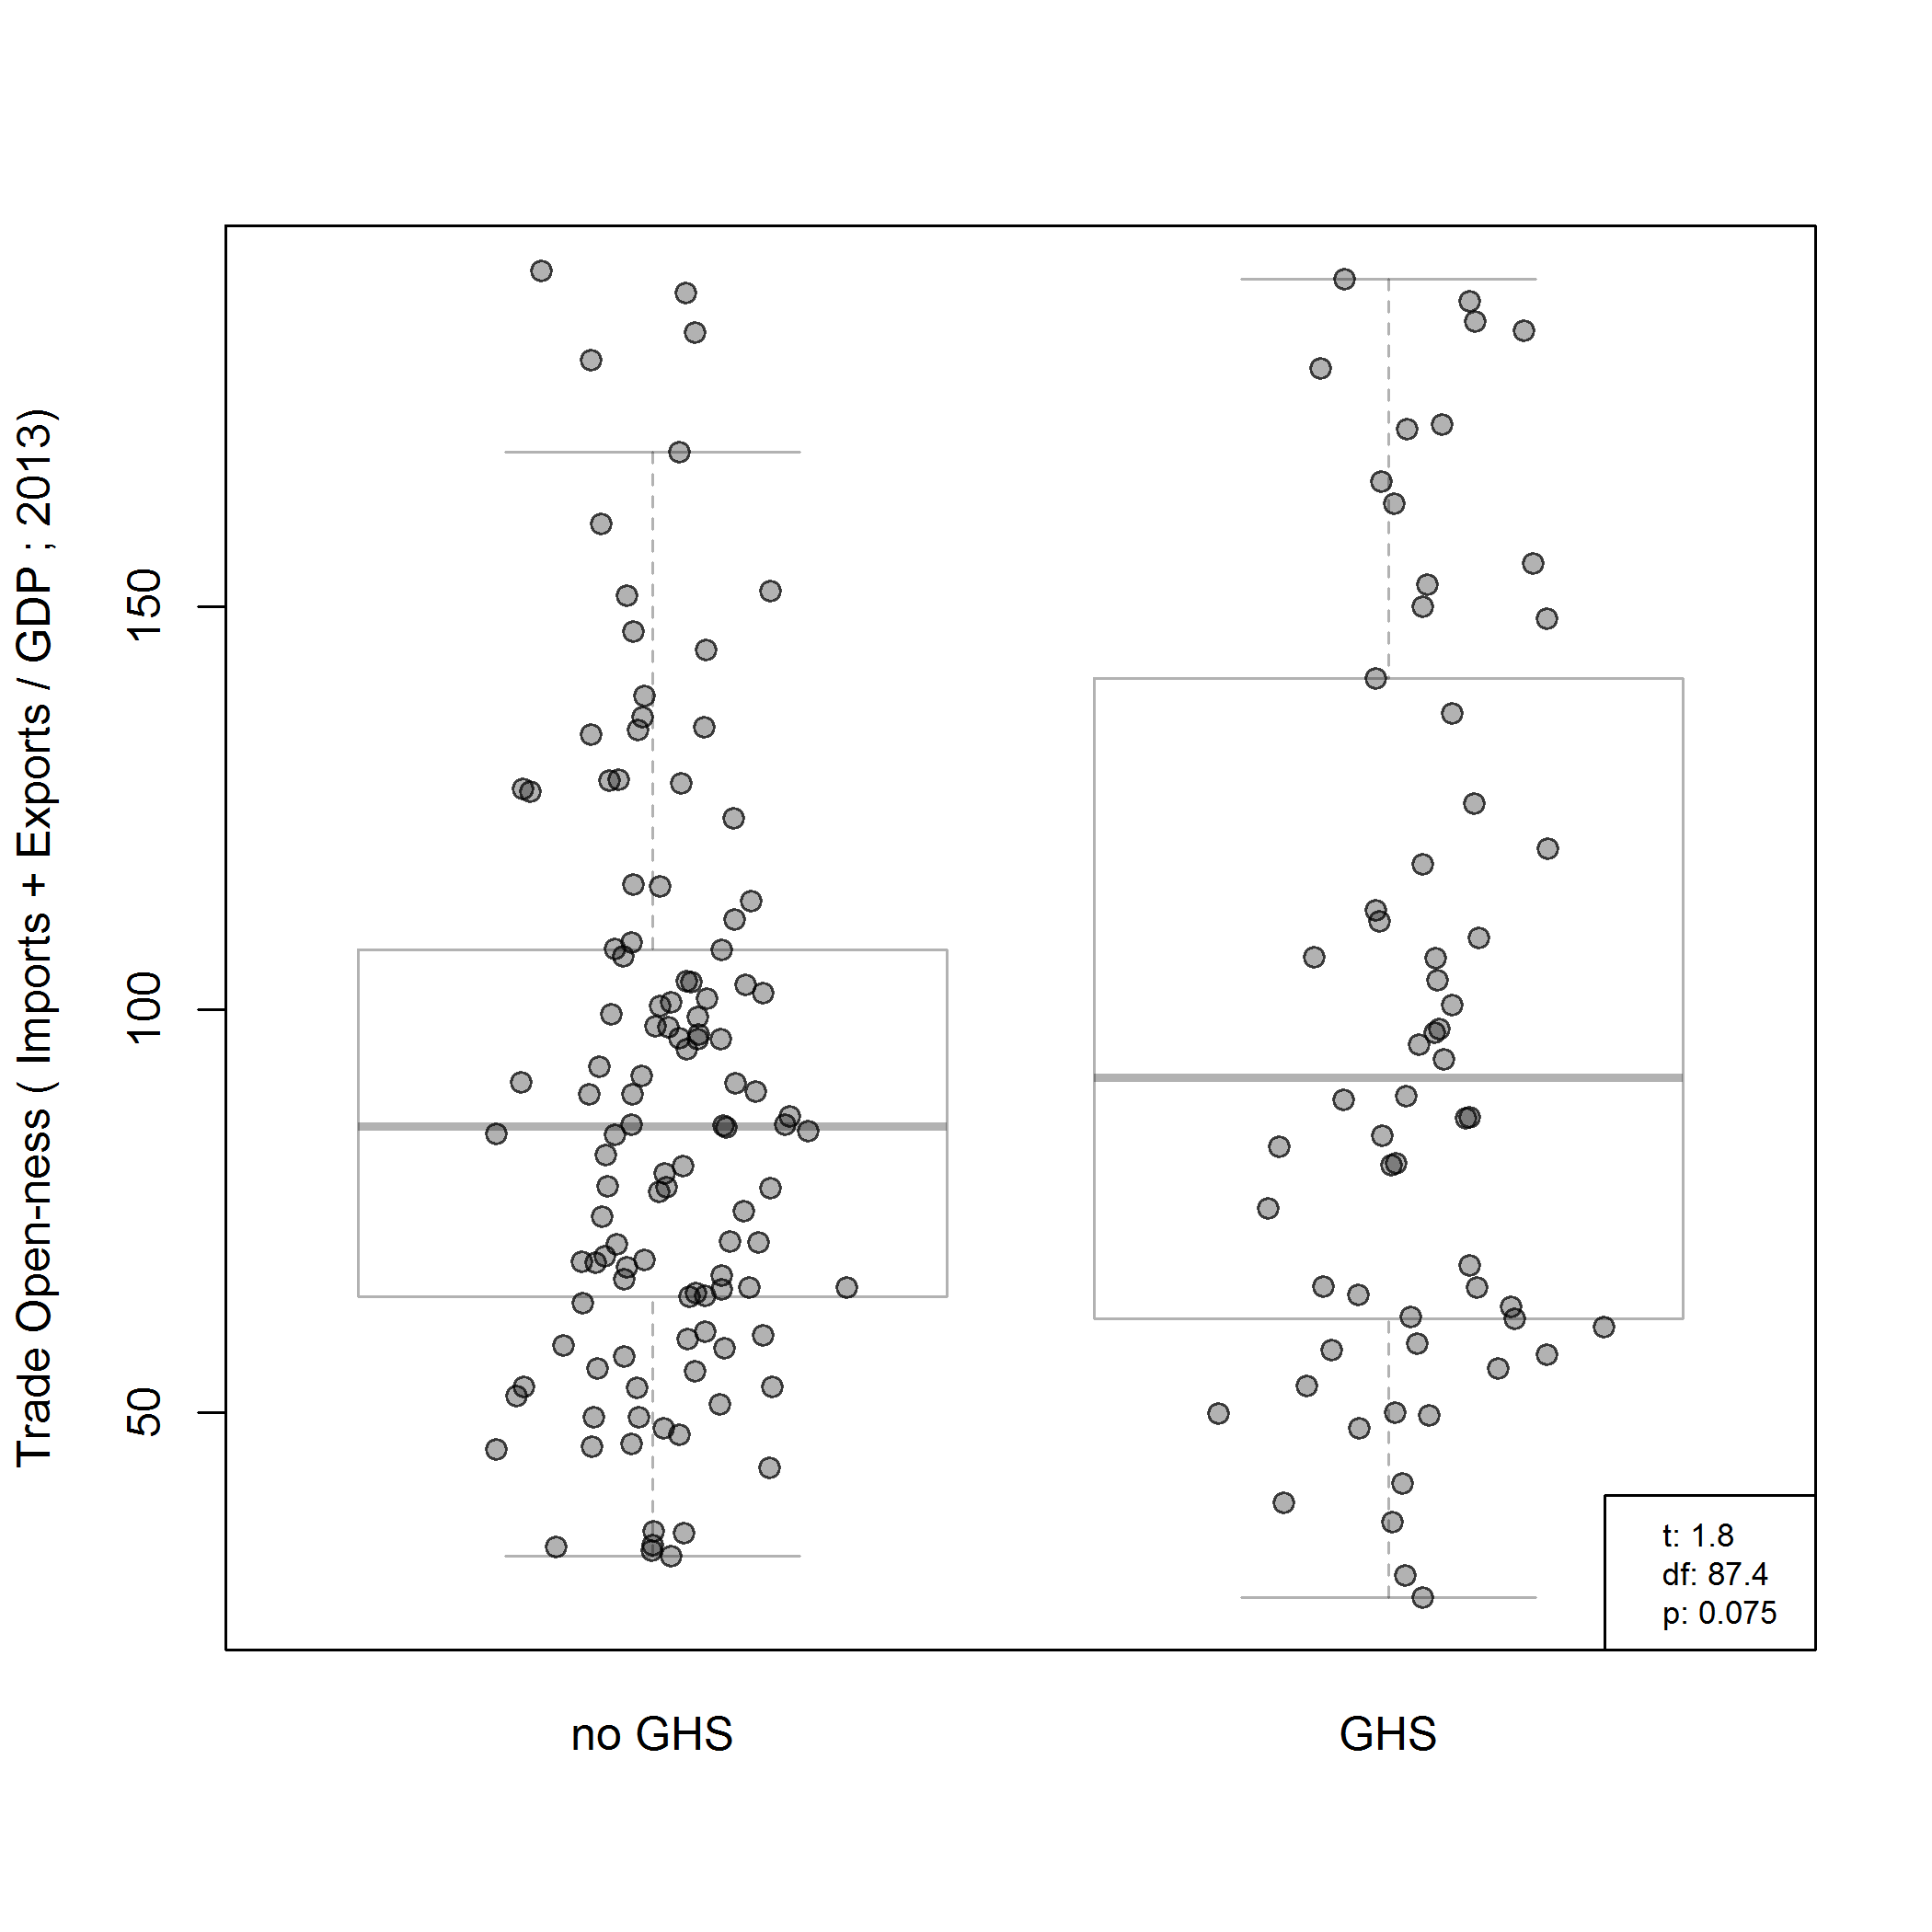

**Figure 2:** Trade openness index and GHS implementation.The UNCTAD STAT indicator of trade openness as sum of import and export of total trade of goods and services as percentage of GDP for most recent available year (2011- 2013) [36]. Each dot represents a country. T is the test statistic, df is the degrees of freedom and p is the probability.

4.1.2. Commitment to occupational safety

Only five countries have ratified all three ILO conventions that we use as indicator for commitment to occupational safety and only 14 have ratified two of them (Table 5). Moving from countries not having ratified any of the ILO conventions to the group that ratified 1, 2 or all of them, GHS implementation frequency increases (Table 3). Judging from this indicator, a general commitment to occupational health and safety is statistically associated with GHS implementation (measured using at least one convention ratification as a proxy, *X2 = 26.3, df = 1, p < 0.001*), suggesting that motivation for GHS implementation comes at least partly from occupational health and safety concerns. As noted in the theory section, the GHS has its origin in occupational health and safety collaboration within the UN system, and thus a correlation between engagement in this area and GHS can be possibly understood as a consequence of countries having active experts and government officials in the occupational area that have been involved for instance in the ratification and implementation of the ILO conventions, are in a better position to implement the GHS than countries without the previous engagement in these ILO conventions.

**T**able : Countries grouped according to the number of ILO conventions they have ratified by GHS implementation (full or partial), or no GHS implementation.

|  |  |  |  |  |
| --- | --- | --- | --- | --- |
|  | **No ILO conventions ratified** | **1 ILO convention ratified** | **2 ILO conventions ratified** | **3 ILO conventions ratified** |
| Countries implementing GHS (fully or partially) | 23 (20%) | 28 (49%) | 10 (71%) | 4 (80%) |
| Countries not implementing GHS | 94 | 29 | 4 | 1 |
| Total number of countries | 117 | 57 | 14 | 5 |

4.1.3. Commitment to the sound management of chemicals

A general commitment to sound management of chemicals as a motivational factor is indicated here through the ratification of three of the chemical conventions as well as of the nomination of a national focal point for the SAICM process. The conventions all have high ratification levels, with only 14 countries not having ratified the Stockholm convention, and nine and 35 countries the Basel and Rotterdam conventions, respectively. Likewise, most countries have also committed to the SAICM process by nominating a national SAICM focal point (178 focal points representing UN member states) (Table 4). It was observed that states scoring low on this indicator are mostly small and fragile states in ongoing or recent conflict. It should also be noted that the US has signed all three conventions but not ratified any of them[6]. The conclusion from this indicator is that ratification and commitment to the SAICM is generally high across countries, and therefore it does not appear to be a strong explanatory factor for GHS implementation *(X2 = 4.0094, df = 2, p = 0.1347).* On the other hand, one could consider the high overall support for SAICM as one of the contributing motivating factors behind the countries that have chosen to implement GHS.

**T**able 4: Ratification1 of chemicals conventions and nomination of SAICM focal point

|  |  |  |  |
| --- | --- | --- | --- |
|  | **Score****2 0-2** | **Score 3** | **Score 4** |
| Countries implementing GHS (fully or partially) | 2 (13%) | 9 (30%) | 54 (37%) |
| Countries not implementing GHS | 14 | 21 | 93 |
| Total number of countries | 16 | 30 | 147 |

1 Ratification, acceptance, approval or accession as of 2nd May 2017 of the Stockholm Convention on Persistent Organic Pollutants (2004)[45], the Rotterdam Convention on Prior Informed Consent (2004)[46] and the Basel Convention on the Control of Transboundary Movements of Hazardous Wastes and their Disposal (1992) [47].

2 The score is calculated with the ratifications of the three conventions and the SAICM focal point each giving one point, thus a total possible score of 4.

4.1.4 Commitment to international cooperation

The commitment to international cooperation in general as an explanatory factor is here measured through the KOF sub-index on political globalization [38,39]. Countries with GHS implementation have statistically higher political globalization scores (Figure 3). A country that in general chooses to be part of international treaties, is a member of many international organisations in different fields, and is open for diplomatic relations with other countries, is thus more likely to implement the GHS than countries who score lower on this indicator. The causality cannot be determined in this study, and it if of course possible that countries that score lower on this indicator do so for reasons that are the same or different compared to the reasons for countries without GHS not to have implemented it yet. Regardless of the causality, this is an important factor to take into account if aiming to assist countries with GHS implementation. Countries that score low on this indicator, and thus have fewer contacts and interactions with other countries, may for example need development assistance with a different design than countries that score higher on this indicator and thus have more experience of international interaction. From another angle, it is of course interesting to ask if the countries that score low on this indicator do so by “choice”, or if the international cooperation is not there because of other reasons, such as other countries not engaging with them.

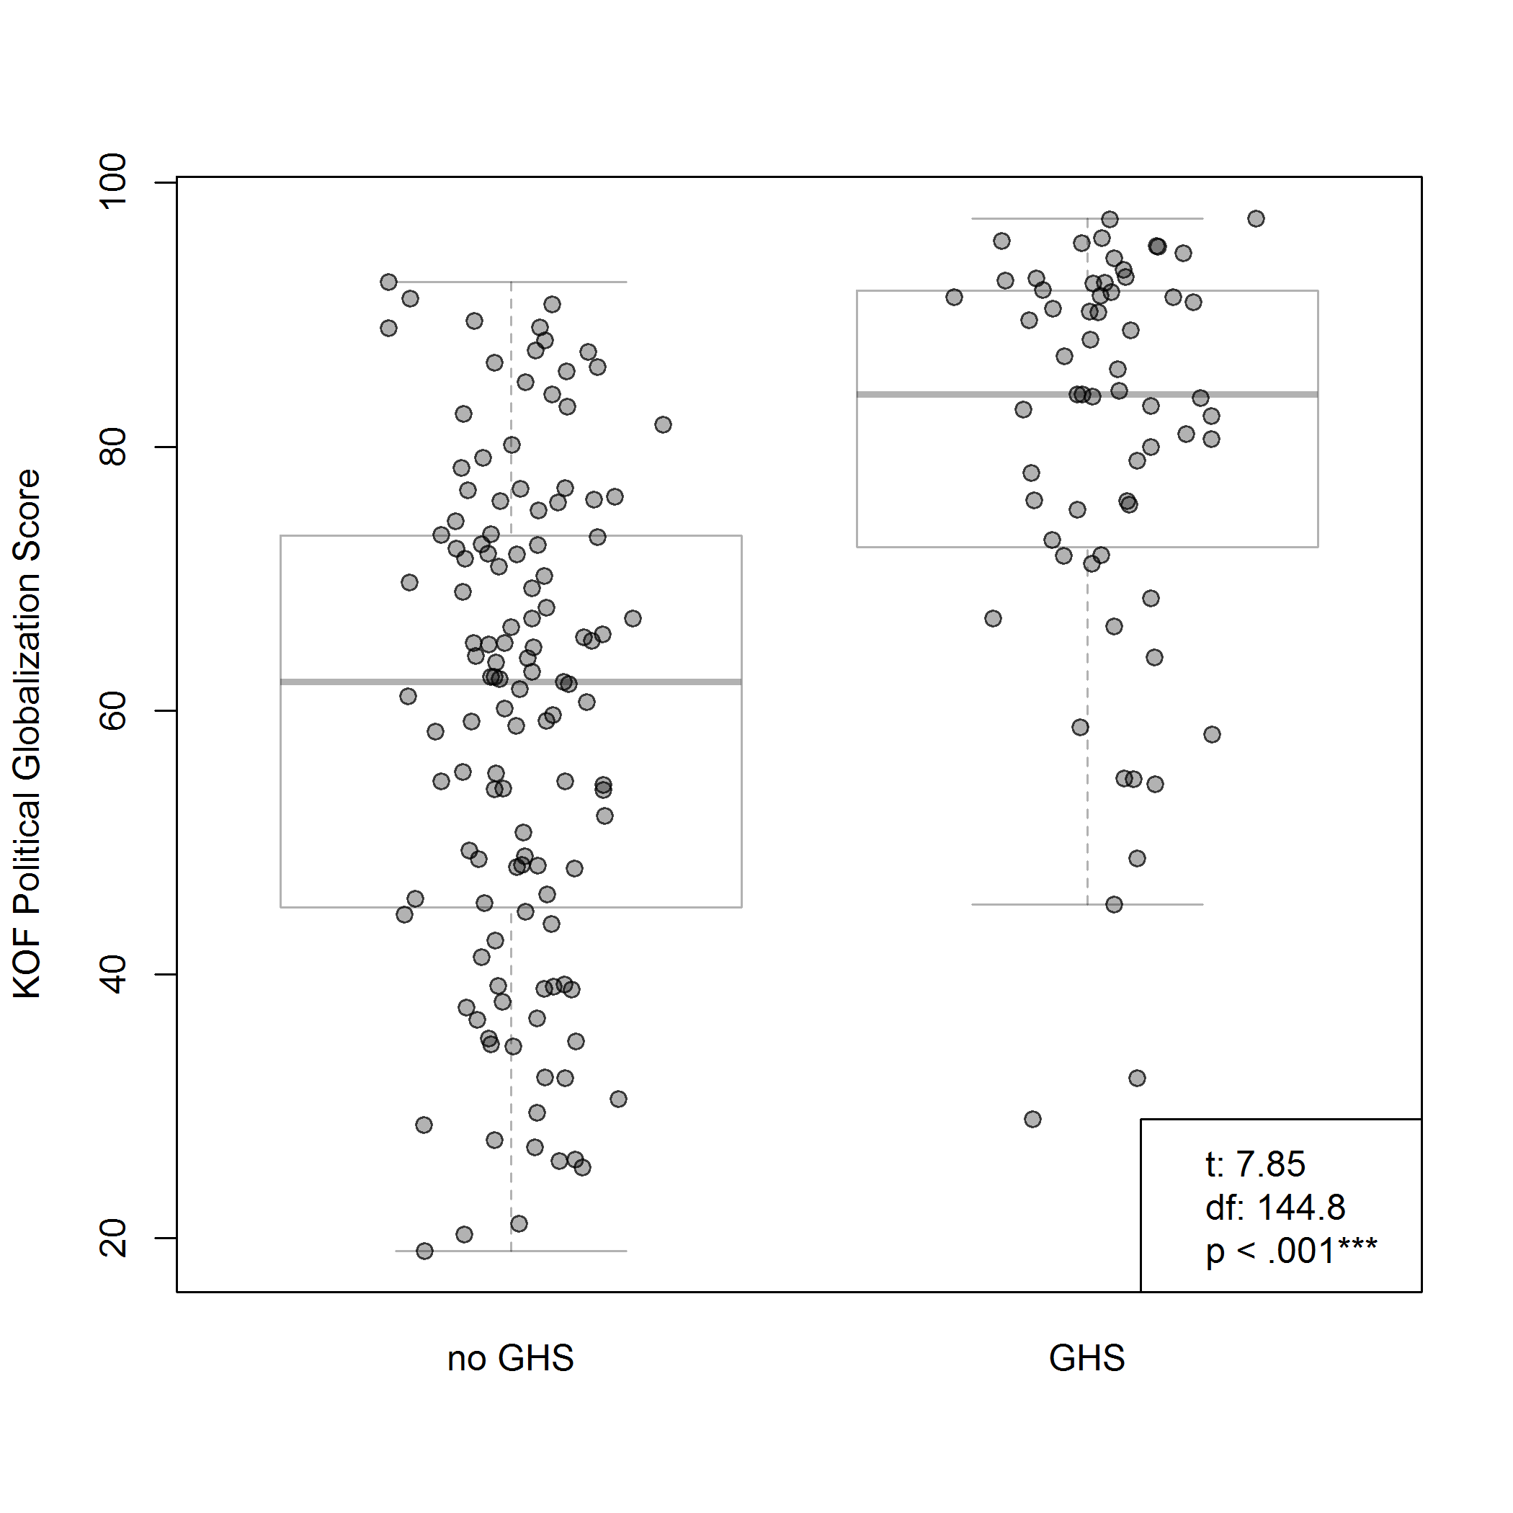

**Figure 3:** KOF index of globalization for year 2014 [38,39] vs GHS implementation. Each dot represents a country. t is the test statistic, df is the degrees of freedom and p is the probability.

4.2 Capacity related factors

4.2.1 Financial capacity

Comparing GHS implementation status to GDP per capita, a positive correlation is found (Figure 4, pane a). Among the countries which have implemented the GHS, most have a higher GDP per capita than the countries that have not implemented the GHS. There are some outliers in terms of a small group of countries with low GDP that have implemented GHS. The countries with the lowest GDP per capita having implemented GHS are the Kyrgyz Republic and Zambia (both below 4000 current international dollars). However, most of the countries (all but 10) having implemented GHS are found at GDP per capita above 14000 current international dollars. Among the countries without GHS, there are also a few countries with high relative GDP per capita.

Turning to the other indicator, the total GDP of countries (Figure 4, pane b), the association is less strong compared to the GDP per capita. Overall, these indicators suggest that there is indeed an important financial capacity related component when explaining the global GHS implementation pattern.

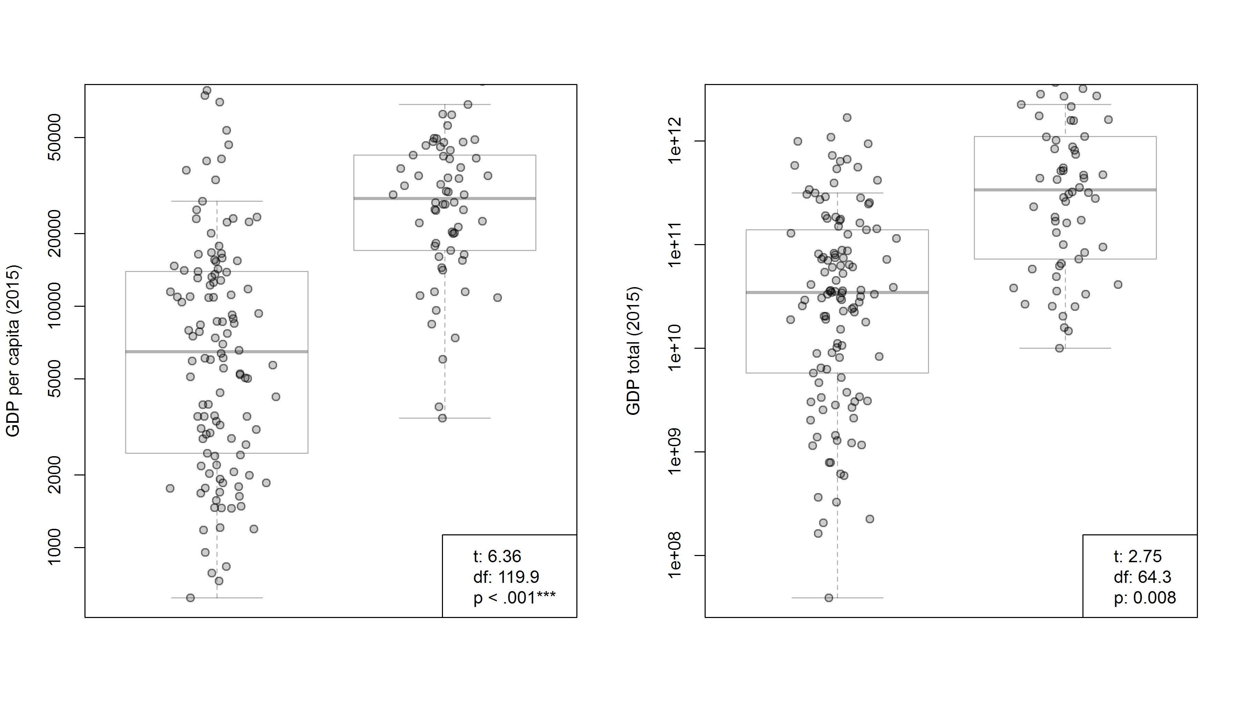

**F**igure : GDP vs GHS implementation per income category of countries, pane a showing GDP per capita and pane b showing total GDP, in logarithmic scale. The data (in Purchasing Power Parity, current international dollars, for 2015) are from the World Bank data depository for both GDP per capita [48] and total GDP [49]. Each dot represents a country. t is the test statistic, df is the degrees of freedom and p is the probability.

4.2.2. Regulatory capacity

The regulatory capacity as measured with the indicator on government effectiveness is positively associated with the GHS implementation status across countries (Figure 5). This means that the ability to formulate and introduce legislation seem to be important in terms of enabling countries to implement the GHS.

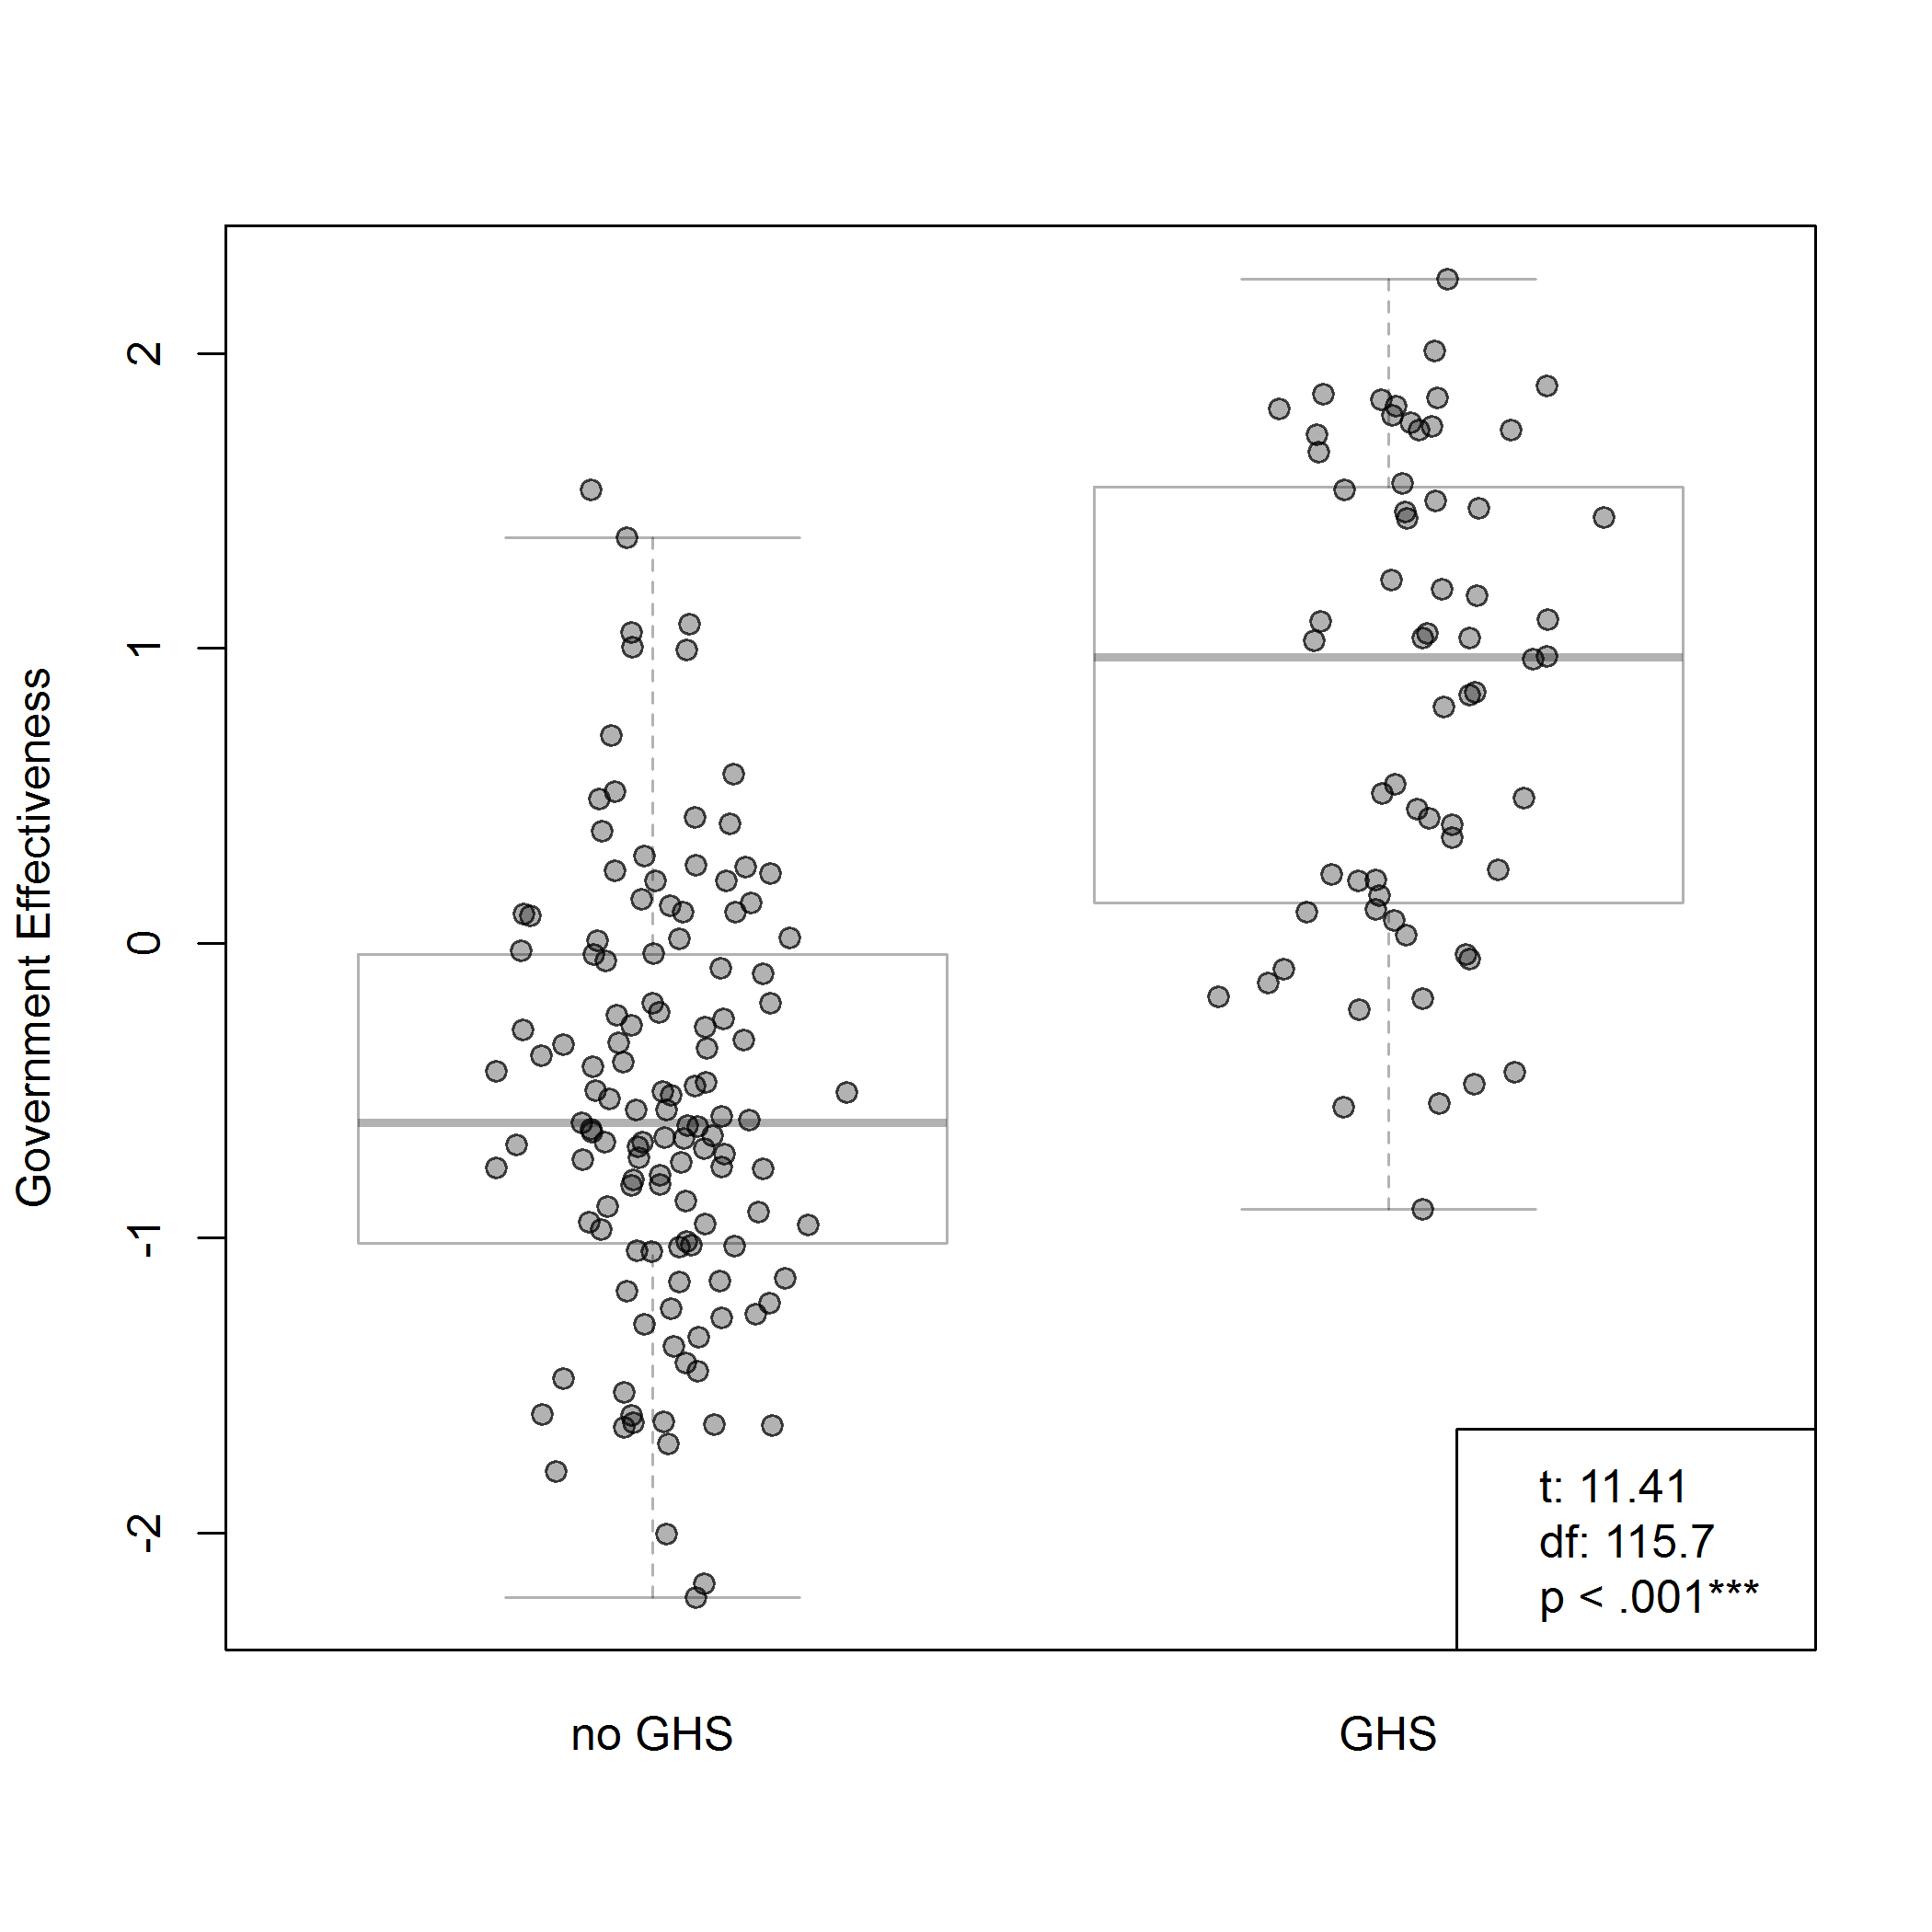

**F**igure : Government effectiveness and GHS implementation. The indicator on government effectiveness is sourced from the Worldwide Governance Indicators project with data for 2015 [40] . Each dot represents a country. t is the test statistic, df is the degrees of freedom and p is the probability.

A possible confounding factor here is that the state of the chemicals legislation in a country prior to the GHS implementation may influence the regulatory difficulty in two directions. If there is very little existing regulation in the field of chemicals, this may make GHS implementation easier, because the GHS can then be introduced as a full package, “straight from the shelf”. Existing regulation that partly overlaps with the GHS related issues may make it a regulatory more complex task to introduce all of GHS, or some of the building blocks, and achieving a coherent legislation as an end result. On the other hand, the existence of earlier chemicals legislation means that there is a certain level of competence in the departments and authorities responsible for this legislation, which may constitute an important regulatory capacity when initiating, planning and designing the GHS implementation [see also 50].

4.3 Comparison across indicators

Testing explanatory factors together revealed that both motivational and capacity related factors appear to be independently associated with the likelihood of GHS implementation. Based on logistic regression analysis, government effectiveness was the strongest predictor of GHS implementation status, followed by political globalization and commitment to occupational safety (Table 5). While trade openness was also significantly related to GHS status after accounting for other indicators, WTO membership was not. Total GDP, GDP per capita, and commitment to sound management of chemicals were not significantly associated with GHS implementation, after accounting for other variables (Table 5). It should be noted that the associations identified in this analysis are general and cannot be translated to degrees of causality without further exploration of confounding factors and other country-level idiosyncrasies, for example via in-depth interviews with government officials and other stakeholders.

**Table 5**. Factors explaining GHS implementation pattern, indicator results

|  |  |  |  |  |
| --- | --- | --- | --- | --- |
|  |  |  | **Combined evaluation** | |
| Factor | Indicator | Individual indicator assessment | Regression coefficient (p-value)1 | Ranking |
| Motivational |  |  |  |  |
| *Reduction of trade barriers* | WTO membership | X2=5.66  p=0.017 | -0.783 (0.400) | Not significant |
|  | Trade Open-ness Index | t=1.8  p=0.075 | 0.850 (0.031) | 4 |
| *Commitment to occupational safety* | ILO conventions ratified | X2=26.3  p<0.001 | 1.726 (0.003) | 2 |
| *Commitment to sound management of chemicals* | Chemical conventions ratified | X2=4.01  p=0.1347 | 0.355 (0.470) | Not significant |
| *Commitment to international cooperation* | KOF sub-index on political globalization | t=1.8  p<0.001*** | 1.664 (< 0.001) | 3 |
| Capacity related factors |  |  |  |  |
|  |  |  |  |  |
| *Financial capacity* | Total GDP  GDP/capita | t=2.75  p=0.008  t=6.36  p<0.001*** | 0.302 (0.446)  -0.654 (0.191) | Not significant  Not significant |
| *Regulatory capacity* | Government Effectiveness | t=11.41  p<0.001*** | 2.590 (< 0.001) | 1 |

1 Regression coefficients represent expected change in log odds of GHS implementation for one standard deviation increase of continuous variables or alternate category of categorical variables. P-values calculated using the Wald test. Model AIC = 111.47, Null deviance = 218.322, Residual deviance = 98.705.

5. Discussion and conclusions

We have shown that there are significant regional differences in GHS implementation coverage. The summarized results of the indicator testing above, showed that government effectiveness stands out as a key factor in this indicator set that is generally associated with GHS implementation. While GDP per capita was not a significant predictor of GHS implementation after accounting for other variables in the regression, it was statistically associated with GHS status by itself, as well as highly correlated with government effectiveness (0.74). Due to this expectedly strong relationship between financial and regulatory capacity, it is fair to say that both likely play a role in GHS implementation, although regulatory capacity appeared to be more directly associated in our data. For the motivational factors, the commitment to international collaboration and to occupational health and safety stand out as important factors for countries, as well as the degree of trade openness.

Although our proposed indicators appear to statistically account for a large proportion of variation in GHS status outcomes (R2=0.57), there are undoubtedly other factors influencing GHS implementation. It is instructive to examine countries that, based on their combined levels of indicators, would be unlikely to implement GHS but have implemented it regardless (high ”residuals” with GHS). These countries include the Kyrgyz Republic, Ecuador, Georgia, Indonesia, Kazakhstan, Zambia, Belarus, Philippines, Armenia, Greece, Montenegro, Malta, Bosnia and Herzegovina, Albania and Mexico. Let’s explore some additional circumstances that may influence implementation with a starting point in these “unexpected” implementers. Greece is a member of the European Union and thus obliged to implement the GHS. Albania, Georgia and Bosnia and Herzegovina are European countries with aspiration to increase collaboration with the European Union, and where GHS implementation is part of a legislative alignment that will support the accession process. An aspiration to join a community may have a broad political support in a country and pull together available resources needed in several topic areas for preparing the accession. This has been seen earlier for e.g. Montreal Protocol implementation where accession to the EU served as an important motivating factor for several countries [51]. Four other countries, Armenia, Kazakhstan, Belarus and the Kyrgyz Republic have decided to introduce joint legislation implementing GHS as part of the Eurasian Economic Union (EAEU). Mexico is another example, and here it is not unlikely that the collaboration within the North American Free Trade Agreement (NAFTA) has played a role as a motivational factor for Mexico, aligning the GHS requirements for the workplace with the US and Canada. In all these cases, collected data suggest that the aspiration to join, or the membership in, a regional trade organization, may play the role of a powerful “pull factor” for GHS implementation.

In this context, it is also important to point out that the European Union with its joint chemicals regulations including full legal GHS implementation constitute a special case with no other comparable regional organization. The EU has a history of setting mandatory and high environmental standards in a global comparison, with EU regulations also mandating the sub-national level [52]. The EU member states, at this moment in time 28, make out the majority of the 50 countries with full legal GHS implementation in this study. In addition, as noted above, the EU also influences other countries outside the EU which may increase these countries motivation to implement GHS. EU may thus have influenced the global implementation pattern mapped in this study in a way that may not be completely transparent in the presented indicators.

Going back to the list of “unexpected implementers”, Zambia is one of only two countries in the African region that have implemented the GHS in national legislation. Here it seems that sustained capacity building and donor support for the GHS implementation have served as a factor of importance. Zambia has received support from UNITAR under the SAICM Quick Start Program (QSP) [53] and other donors according to interviews and data collection[7]. It can thus be concluded that sustained capacity building and partnering with donor countries can result in countries with low capacity to implement GHS.

Indeed, the need for capacity building and awareness raising for successful GHS implementation in low income countries has been long standing on the agenda of international collaboration, for instance through the Global partnership for capacity building to implement the GHS [54] and in the continued SAICM process. Among the projects funded under the SAICM QSP several have focused on GHS implementation. Some of these projects are still ongoing, and it is still therefor early to assess the overall success of these efforts. However, interviewees have noted that the limited time frame of the QSP projects is generally not sufficient to render support to a country to follow through to actual GHS implementation in legislation.

This conclusion is supported by the findings of the evaluation of the SAICM QSP [55], which notes that the QSP projects, although having achieved results in many countries could be improved at various points. This includes a clearer focus on building national capacity (if possible avoiding international consultants in favor of national), that can be sustained also after the project is finalized. A follow-up mechanism of clear (and not too many) targets to reach in the years after project completion, as well as increased attention to long term financing of activities, could help not to lose the momentum created by the project. In addition, the evaluation concludes that another key issue is that projects have not always been designed for the specific needs of a specific country to the extent required. Thus, for GHS implementation capacity, as for all other capacity building, interventions have to be carefully designed for the specific context in order to achieve the expected outcome. The evaluation also noted that for many countries, the chemicals agenda cannot always compete with other pressing priorities in final decisions on distribution of resources in the national administration [55].

In the example of Barbados, which had a QSP funded project implemented by UNITAR that resulted in a detailed national implementation strategy, this last point was confirmed. The government official reported in the interview that after the strategy was approved in 2013, most of the planned activities did not yet take place because of delays in approval of the plan from the political level as well as limited human and financial resources for the planned activties, which in turn was explained by competing political priorities at the national level.

It is in this context interesting to note that the commitment to the chemicals and waste agenda as measured with the indicator on convention ratification, was overall very high among countries, but not strongly correlated to the implementation of GHS. This can be interpreted in different ways, but it is possible that a general commitment to ratifying conventions and participating in international processes is less resource demanding than an actual GHS implementation, and that this can be a reason for GHS losing the competition against other priorities in the actual budget and planning processes in countries, in spite of a general commitment to sound chemicals management at the political level. Here, we also note that the third step in the implementation process, not covered by this study – the enforcement and compliance – is an additional unknown, i.e. countries may implement GHS in national legislation in order to adhere to their commitments under e.g. SAICM, but not be motivated to, or have the capacity to, comply and enforce on the ground.

Changing the perspective, we turn to the countries which have not implemented GHS and score high in the indicator set (high “residuals” without GHS). These include India, Chile, South Africa, United Arab Emirates, Jordan, Ukraine, El Salvador, Colombia, the Seychelles and Morocco. Some of these, like South Africa and Chile are actively working on GHS implementation and might soon not be “outliers” anymore. For others, like UAE and Jordan, not much information could be retrieved on the current status, or on the motivation for these countries not to implement GHS. This is something that merits further discussion in the SAICM process and the GHS sub-committee. One possibility here could be that there is a limited buy-in into the GHS process, since the GHS sub-committee has higher participation from European and North American country experts compared to other regions.

We turn lastly to possible options for increasing the rate of global implementation of GHS, and thus increasing the speed of implementation and reducing the costs in terms of human health, ecosystem integrity and socioeconomic loss that comes with unsustainable use of chemicals. We conclude that this cannot be done in the same way for all countries. Some factors will be more important than others depending on the context, and for all countries it is likely that drawing on a combination of different factors is needed to enable and motivate implementation (**T**able 6).

There is one group of countries which score low on all the indicators here presented, such as GDP per capita and political globalization as well as regulatory capacity. Some of these are war-torn, and some are new or fragile states. They all have remaining challenges across the 2030 Agenda. Recalling the message from the evaluation of the SACIM QSP, for these countries it is of key importance to adapt expectations, and address chemicals management and GHS implementation as part of a broader national strategy to work towards the full 2030 Agenda implementation. Other low-income countries that have a more stable situation may benefit from specific capacity building for GHS implementation, but with the prerequisite that lessons learned from earlier design of capacity building as discussed above is taken on board.

**T**able 6. Possible policy options to enhance national GHS implementation

|  |  |  |
| --- | --- | --- |
|  | **Possible options** | **Actors** |
| **Motivation** | Increased regional collaboration on GHS implementation  Engaging new actors with interest in occupational safety  Increased efforts on inclusiveness of the GHS Sub-committee | Regional trade blocs and other regional organisations  ILO, trade unions, private sector actors  UN ECOSOC member countries |
|  | ____________  Supporting improved regulatory capacity | All countries, donors |
| **Capacity** | General capacity building, taking on board lessons learnt | SAICM process, GEF, Governments (donor and recipient countries) |
|  |  |  |
|  | Efforts in overall Agenda 2030 realization | Countries and other stakeholders in the 2030 Agenda process |
|  |  |  |

The opportunities that lie in regional collaboration and coordination around GHS implementation has been highlighted before [see for example 54]. Regional trade blocs and organisations could play a key role here in jointly implementing the GHS or in supporting national implementation processes. Countries within a trade bloc or organisation with more capacity can assist other member states that are less resourced for the implementation [56].

The strong association between GHS implementation and government effectiveness again highlights the fundamental role of functioning institutions in countries for the ability to plan and implement policies. The case of Viet Nam with GHS implementation in place [57,58] is interesting. Viet Nam has been supported by the Swedish Chemicals Agency (KemI) in a continued bilateral collaboration (2005-2013)[59,60], as well as through the regional programme “Towards a non-toxic South-East Asia”, also a long term commitment now in its second phase [61]. One of the outcomes of the collaboration was the establishment of the Viet Nam Chemicals Agency [59,62]. This support is likely to have influenced GHS implementation through parallel institutional strengthening and broad chemicals management capacity building efforts. Indeed, the interviewee from Zambia also expressed that a key factor in the GHS implementation in this country has been that it has not been implemented as a stand-alone component, but been part of a comprehensive chemicals management planning and capacity building.

For countries with higher income, where the lack of implementation is not likely to be caused by lack of capacity, the increased rate of implementation must come from renewed or new motivation. Here it may be worthwhile to explore the role of private sector actors and trade ministries in lifting the benefits in increased harmonization for trade as a way to gain political support for GHS implementation. Likewise, the strong motivation to implement GHS that seems to come from occupational health and safety concerns could also be drawn upon in engaging more with stakeholders such as trade unions and other actors with strong buy-in in occupational issues as a driver for GHS.

To allow further probing into the barriers and opportunities of specific countries for GHS implementation, a more qualitative research approach would be a valuable complement to the more quantitative methodology of this paper. Such an approach would entail more in-depth interviews with various stakeholders, and would allow for more detailed answers as to causality of different factors. It would also allow for a discussion about regional contexts, and how these may require, or open for, different roads to increased implementation.

Summing up some of the insights from the present study, in order to improve the implementation coverage, low capacity needs to be increased through support, taking lessons learned from what is effective capacity building into account, and especially recognizing the importance of regulatory capacity. The strengthening of chemicals management should be addressed as part of the overall Agenda 2030 efforts in all countries, but it is of highest importance for the countries with lowest capacity. Further, drawing upon the potential in GHS as part of occupational health and safety commitment and as a way to reduce trade barriers, especially in a regional context, seems like promising options for increased GHS implementation across countries and regions with increased sustainability as one of the outcomes.

**Supplementary Materials:** The following are available online at www.mdpi.com/link, Table S1: Dataset on GHS implementation status by country with links to national legislation. The statistical analysis is available at <https://github.com/sei-international/GHS>.

**Acknowledgments:** The research was funded primarily by the Swedish International Development Cooperation Agency, including the costs to publish in open access. Åsa Persson’s contribution was funded by the Swedish Research Council Formas, grant no. 211-2012-1842. Mr. Lennart Dock and colleagues at the Swedish Chemicals Agency, Ms. Rosa Garcia Couto at the Secretariat of the GHS Sub-committee and Mr. Oliver Wootton at UNITAR provided valuable input during the study. The responsibility of the analysis and the results remain with the authors.

**Author Contributions:** Linn Persson initiated the research GHS implementation and Adelene Lai and Åsa Persson took part in initial research design and set-up. Sylvia Karlsson-Vinkhuyzen was responsible for the theoretical framing of the study. L. Persson and A. Lai completed the data collection on GHS implementation and the indicators. Stephen Fick contributed with the statistical analysis of the indicators and their graphic representation. The analysis of the results was carried out jointly by the authors.

**Conflicts of Interest:** The authors declare no conflict of interest.

References

1. UN GHSSC GHS implementation, Secretariat of the Sub-Committee of experts of the GHS (GHSSC). http://www.unece.org/trans/danger/publi/ghs/implementation_e.html (accessed 1 April 2017) 2017.

2. UNCED *Agenda 21*; 1992;

3. Pruss-Ustun, A.; Wolf, J.; Corvalan, C.; Bos, R.; Neira, M. Preventing disease through healthy environments - A global assessment of the burden of disease from environmental risks. World Health Organisation. 2016.

4. UNEP *Costs of Inaction on the Sound Management of Chemicals*; United Nations Environment Programme, 2013;

5. UNEP *Global Chemicals Outlook, towards sound management of chemicals. United Nations Environment Programme (UNEP).*; United Nations Environment Programme, 2013;

6. UN *The Johannesburg Plan of Implementation of the World Summit on Sustainable Development.*; 2002;

7. ECOSOC Reconfiguration of the Committee of Experts on the Transport of Dangerous Goods into a Committee of Experts on the Transport of Dangerous Goods and on the Globally Harmonized System of Classification and Labelling of Chemicals. Resolution 1999/65 of the UN Economic and Social Council. 1999.

8. UN Report of the sub-committee of experts on its first session. Sub-committee of experts on the Globally Harmonised System of classification and labelling of chemicals, 9-11 Juy 2001. ST/SG/AC.10/C.4/2. 2001.

9. UN Globally Harmonised System of Classification and Labelling of Chemicals (GHS, Rev. 7), July 2017. 2017.

10. UN Committee of experts on the transport of dangerous goods and on the globally harmonized system of calssification and laeblling of chemicals, Sub-committee of experts on the Globally Harmonized System of Classification and Labelling of Chemicals. Report of the sub-committee of experts on its fourth session, 9-11 December 2002. ST/SG/AC.10/C.4/8 7 February 2003. 2003.

11. UNECE About the GHS, Globally Harmonized System of Classification and Labelling of Chemicals (GHS). https://www.unece.org/trans/danger/publi/ghs/ghs_welcome_e.html (accessed 16 May 2017) 2017.

12. Kerwer, D. Rules that Many Use: Standards and Global Regulation. *Governance* **2005**, *18*, 611–632, doi:10.1111/j.1468-0491.2005.00294.x.

13. SAICM *SAICM (The Strategic Approach to International Chemicals Management). Texts and resolutions of the International Conference on Chemicals Management in 2006*; United Nations Environment Programme and the World Health Organization: Geneva, Switzerland, 2006;

14. Karlsson-Vinkhuyzen, S. Global Regulation Through a Diversity of Norms: Comparing Hard and Soft Law. In *Handbook on the Politics of Regulation*; Edward Elgar: Cheltenham, UK, 2011; pp. 604–614.

15. *The politics of global regulation*; Mattli, W., Woods, N., Eds.; Princeton University Press: Princeton, 2009; ISBN 978-0-691-13960-9.

16. UNEP Overall orientation and guidance for achieving the 2020 goal of sound management of chemicals. SAICM/ICCM.4/6. Advance copy 2015.

17. UN *Recommendations on the transport of dangerous goods: model regulations, volumes i & ii. United Nations (UN). 20th revision, 2017.*; UNITED NATIONS: S.l., 2017; ISBN 978-92-1-139159-6.

18. Peterson, P. J.; Mokhtar, M. bin; Chang, C.; Krueger, J. Indicators as a tool for the evaluation of effective national implementation of the Globally Harmonized System of Classification and Labelling of Chemicals (GHS). *J. Environ. Manage.* **2010**, *91*, 1202–1208, doi:10.1016/j.jenvman.2010.01.008.

19. Ta, G. C.; Mokhtar, M. B.; Peterson, P. J.; Yahaya, N. B. A Comparison of Mandatory and Voluntary Approaches to the Implementation of Globally Harmonized System of Classification and Labelling of Chemicals (GHS) in the Management of Hazardous Chemicals. *Ind. Health* **2011**, *49*, 765–773, doi:10.2486/indhealth.MS1258.

20. SAICM National SAICM Focal Points as of March 2017, see list at http://www.saicm.org/Implementation/FocalPoints/tabid/5461/language/en-US/Default.aspx (accessed 21 April 2017) 2017.

21. CEFIC Global GHS implementation task force - overview of GHS implementations, May 2014, European Chemical Industry Council (Cefic). 2014.

22. DHI GHS implementation, world map. Web site http://ghs.dhigroup.com/GHSImplementatationMap.aspx (accessed 1 November 2016). 2016.

23. UNEP Baseline estimates report 2006-2008: Progress in the implementation of the Strategic Approach on International Chemicals Management. SAICM/ICCM.3/INF/5. 2012.

24. R Core Team *R: A Language and Environment for Statistical Computing.*; R Foundation for Statistical Computing: Vienna, Austria, 2016;

25. Box, G. E. P.; Hunter, W. G.; Hunter, J. S. *Statistics for experimenters: design, innovation, and discovery*; Wiley series in probability and statistics; 1st ed.; John Wiley & Sons, Inc.: Hoboken, N.J, 1978;

26. Finnemore, M.; Sikkink, K. International Norm Dynamics and Political Change. *Int. Organ.* **1998**, *52*, 887–917, doi:10.1162/002081898550789.

27. Raustiala, K. Compliance and effectiveness in international regulatory cooperation. *Case W Res Intl L* **2000**, *32*, 387–440.

28. Karlsson-Vinkhuyzen, S. I.; Vihma, A. Comparing the legitimacy and effectiveness of global hard and soft law: An analytical framework. *Regul. Gov.* **2009**, *3*, 400–420, doi:10.1111/j.1748-5991.2009.01062.x.

29. Vihma, A.; Mulugetta, Y.; Karlsson-Vinkhuyzen, S. Negotiating solidarity? The G77 through the prism of climate change negotiations. *Glob. Change Peace Secur.* **2011**, *23*, 315–334, doi:10.1080/14781158.2011.601853.

30. Boyle, A. E.; Chinkin, C. M. *The making of international law*; Foundations of public international law; Oxford University Press: Oxford ; New York, 2007; ISBN 978-0-19-924819-3.

31. Kirton, J.; Trebilcock, M. Introduction: Hard Choices and Soft Law in Sustainable Global Governance. In *Hard Choices, Soft Law: Voluntary Standards in Global Trade, Environment and Social Governance*; Bodmin: Cornwall, Ashgate, 2004.

32. Guzman, A. T. A Compliance-Based Theory of International Law. *Cal R* **2002**, *90*, doi:10.15779/Z388728.

33. Mattli, W.; Büthe, T. Setting International Standards: Technological Rationality or Primacy of Power? *World Polit.* **2003**, *56*, 1–42, doi:10.1353/wp.2004.0006.

34. Wijkström, E.; McDaniels, D. Improving Regulatory Governance: International Standards and the WTO TBT Agreement. *J. World Trade* **2013**, *47*, 1013–1046.

35. Braithwaite, J.; Drahos, P. *Global business regulation*; Cambridge University Press: Cambridge [England] ; New York, 2000; ISBN 978-0-521-78033-9.

36. UNCTAD United Nations Conference on Trade and Development (UNCTAD), UNCTADSTAT, indicator of trade openness, as percentage of GDP, for year 2013 (BPM%). http://unctadstat.unctad.org/wds/TableViewer/tableView.aspx (accessed 28 April 2017). 2017.

37. Standing, G. The International Labour Organization. *New Polit. Econ.* **2010**, *15*, 307–318, doi:10.1080/13563460903290961.

38. Dreher, A. Does globalization affect growth? Evidence from a new index of globalization. *Appl. Econ.* **2006**, *38*, 1091–1110, doi:10.1080/00036840500392078.

39. Dreher, A.; Gaston, N.; Martens, P. *Measuring globalisation: gauging its consequences*; Paperback repr.; Springer: New York, NY, 2008; ISBN 978-0-387-74069-0.

40. Kaufmann, D.; Kraay, A.; Mastruzzi, M. Policy research working paper 5430, the Worldwide Governance Indicators, Methodology and Analytical issues. The World Bank, Development Research Group, Macroeconomics and Growth Team, September 2010. 2010.

41. SADC SADC GHS policy, draft 3, February 2011. 2011.

42. UNITAR Regional workshop on chemical hazard communication and GHS implementation for Arab countries, 30 October - 2 November 2006. FInal report. UNITAR/ILO. 2006.

43. ChemicalWatch Chemicals regulation in the Middle East - an overview. Global Business Briefing, May 2009, by Tamar Szepts-Znaider, 3E Company. 2009.

44. WTO WTO accessions. World Trade Organisation (WTO). https://www.wto.org/english/thewto_e/acc_e/acc_e.htm (accessed 16 May 2017) 2017.

45. UNEP The Stockholm Convention on Persistent Organic Pollutants (POPs). Texts and Annexes. Amended in 2009 and 2011. www.pops.int. 2001.

46. UNEP *Rotterdam convention on the Prior Informed Consent Procedure for certain hazardous Chemicals and Pesticides in international trade. Text and annexes, revised 2011.*; United Nations Environment Programme (UNEP) and the Food and Agricultural Organisation (FAO)., 1998;

47. UNEP Basel convention on the control of transboundary movements of hazardous wastes and their disposal. Texts and annexes. http://www.basel.int/Portals/4/Basel%20Convention/docs/text/BaselConventionText-e.pdf 1989.

48. World Bank GDP per capita, PPP (current international dollars), the World Bank international comparison program. http://data.worldbank.org/indicator/NY.GDP.PCAP.PP.CD (accessed 29 April 2017) 2015.

49. World Bank GDP, PPP (current interntional dollars), World Bank, International Comparison Program Database. http://data.worldbank.org/indicator/NY.GDP.MKTP.PP.CD (accessed 29 APril 2017) 2017.

50. European Commission Study on the regulatory fitness of the legislative framework governing the risk management of chemicals (excluding REACH), in particular the CLP Regulation and related legislation, Case study 1: Comparison of implementation of UN GHS in the eu and other key economies. 2017.

51. SEI Swedish bilateral programme under the Montreal Protocol. Summary of programme activties 1999-2008. Project report, Stockholm Environment Institute. 2008.

52. Selin, H.; VanDeveer, S. D. *European Union and environmental governance*; Routledge global institutions series; Routledge: Abingdon, Oxon ; New York, NY, 2015; ISBN 978-0-415-62881-5.

53. ICCM Decision adopted on 6 February 2006 by the International Conference on Chemicals Management at its first session, Dubai, United Arab Emirates, 4-6 February 2006. International Conference on Chemicals Management (ICCM). http://www.saicm.org/Portals/12/Documents/ICCM%20decision%20I.4%20QSP%20Eng.pdf (accessed 15 June 2017) 2006.

54. UNITAR, OECD and ILO The GHS and Global Partnership: a success story from Rio to Rio. WSSD Global Partnership for Capacity Building to Implement the GLobally Hamonised System of Classification and Labelling of Chemicals (GHS). http://www.oecd.org/chemicalsafety/risk-management/50500627.pdf (accessed 28 June 2016) 2012.

55. UNEP Impact evaluation of the Quick Start Programme. SAICM/ICCM.4/INF/5. 2015.

56. Bizikova, L.; Metternicht, G.; Yarde, T. Advancing Environmental Mainstreaming in the Caribbean Region: The Role of Regional Institutions for Overcoming Barriers and Capacity Gaps. *Sustainability* **2015**, *7*, 13836–13855, doi:10.3390/su71013836.

57. ChemicalWatch Vietnam labelling deadline imminent for substances - Two more years left for mixtures. ChemicalWatch New Item, 18 February 2014. https://chemicalwatch.com/18441/vietnam-labelling-deadline-imminent-for-substances (accessed 14 November 2016) 2014.

58. ChemSafetyPRO GHS implementation in Vietnam, ChemSafetyPRO new item, 2016-01-05. http://www.chemsafetypro.com/Topics/Vietnam/GHS_in_Vietnam_SDS_label.html (accessed 14 November 2016) 2016.

59. KemI SEMLA, final project report, number H05-00449-18. Swedish Chemicals Agency (KemI). 2010.

60. Vinachemia and KemI 2013 completion report for partnership program between KemI and Vinachemia. Project report for period 2010-12-01 to 2013-12-31. Vinachemia, Chemicals Agency of Viet Nam and KemI, Swedish Chemicals Agency.

61. KemI Regional Programme: Towards a non-toxic environment in South-East Asia, Phase II. Swedish Chemicals Agency (KemI). Ref number H13-01013, https://www.kemi.se/en/files/96b822bbbfe745deb349438afa289238/progress-report-2015.pdf (accessed 14 November 2016) 2016.

62. Vietnam Chemicals Agency Implementation of Chemical Law in Viet Nam, submitted by Viet Nam, Vietnam Chemicals Agency, Ministry of Industry and Trade. Case Study Workshop on the Chemicals Sector - From Principles to Practice Hiroshima, Japan 1-2 March 2010. http://mddb.apec.org/documents/2010/CDSG/WKSP1/10_cd_wksp1_010.pdf (accessed 14 November 2014) 2010.

H:\documents\layout\new template June 2014\figures\CC-BY logo original v1.wmf© 2017 by the authors. Submitted for possible open access publication under the   
terms and conditions of the Creative Commons Attribution (CC BY) license (<http://creativecommons.org/licenses/by/4.0/>).

1. **Substances** refers to chemical elements and their compounds in the natural state or obtained by any production process. **Mixtures** means a mixture or solution composed of two or more substances in which they do not react. GHS (rev 6), introduction.
2. Searching for e.g.: Name of country+GHS+implementation, Name of country+Globally Hamonized System and also, in cases where these options did not result in any relevant documents, Name of country+chemicals+legislation)
3. There is considerable diversity in terms and concepts essentially referring to similar or identical phenomena in these literatures, but norms are often used as an umbrella term for rules, laws, and principles [26].
4. The Stockholm Convention on Persistent Organic Pollutants (2001), The Basel Convention on the Control of Transboundary Movements of Hazardous Wastes and their Disposal (1989), and the Rotterdam Convention on Prior Informed Consent (1998).
5. The Cooperation Council for the Arab States of the Gulf is a regional organisation, with six member states: The Kingdom of Bahrain, the State of Kuwait, the Sultanate of Oman, the State of Qatar, the Kingdom of Saudi Arabia and the United Arab Emirates. Set up in 1981, its objectives are to enhance coordination, integration and inter-connection among its members.
6. The US Department of State informs on its web site that the US “signed the Rotterdam Convention in 1998, but has yet to ratify because we currently lack the authority to implement all of its provisions. The United States participates as an observer in the meetings of the parties and in technical working groups”, <https://www.state.gov/e/oes/eqt/chemicalpollution/83010.htm> (accessed 3 May 2017).
7. Projects have included Zambia as a pilot country in the Chemical Hazard Communications Project (2001-2002, UNITAR and UN-ILO), the UNDP-UNEO Partnership Initiative with Zambia: Mainstreaming Sound Management of Chemicals Issues into the MDG based National Development Planning (2007-2009, Funding from Government of Sweden), the GHS capacity building project (2011-2012, SAICM QSP/UNITAR)